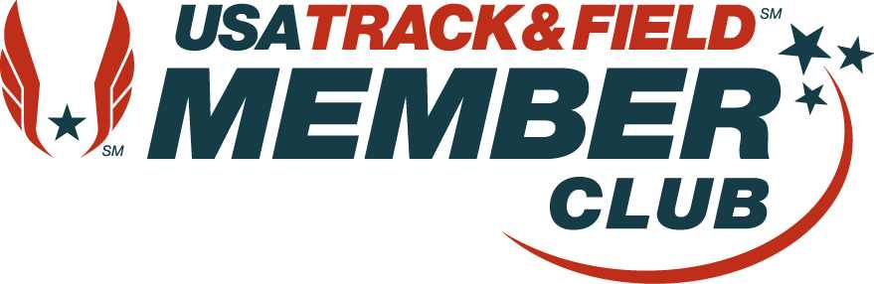 TOWN TRACK CLUB 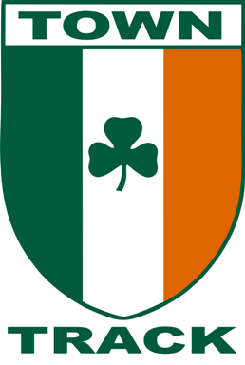
84 Washington Street #1
Charlestown, MA 02129
spnyhan@gmail.com
towntrackclub.com
Sean Nyhan
857-222-5630
FIT KIDS REGISTRATION FORM

Athletes Name________________________________________________________ Sex: M F

Address__________________________________________City___________________State_________Zip Code______

Parent’s CellPhone________________________ Parent’s Email_______________________

Age____Date of Birth___________ Please give grade _____________________________

Name of Parent or Guardian of Applicant (PLEASE PRINT)__________________________________________

As the parent or legal guardian of the above applicant, I fully understand that participation in athletics could result in both minor and serious injury and even death. I further understand that to minimize the risk of injury or harm, the applicant should have had a physical within the past year. I assume any and all risks associated with the above applicant’s participation as a member of the Town Track Club and I hereby waive and release the Town Track Club, its coaches and representatives, of any and all rights for damages or injuries suffered while participating with the Town Track Club during a scheduled practice, conditioning session or competition; while traveling to or from a scheduled practice, conditioning session or competition; or during any other Club related activity. I give the Town Track Club permission to use any picture or photo likeness of me in newspaper releases and related sport articles or on the Club’s Web Site and to distribute, broadcast and exhibit these without charge, restriction or liability, but only for the purpose of advertising or promoting the programs of the Town Track Club and the sport of track and cross country. In no event, however, will such usage constitute an endorsement of any product or service, without my specific written permission.
Signature of parent or guardian of above applicant_____________________________________________________

Dues- 10 week session $180, please leave registration form and check payable to Town Track Club in afterschool box. Or paypal spnyhan@gmail.com
Mondays Afterschool (4:40-5:30)

Town Track Club’s FIT KIDs program teaches a mix of running, coordination, and group play for children grades K- 2nd. Kids engage in game-based fitness activities which include obstacle courses, relays and other fun challenges. The curriculum is age appropriate and has been used as pre-seasoning conditioning for youth sports programs including Youth XC/Track, Soccer, and Tennis. Coach Sean Nyhan is a USATF Level 2 certified Coach with a youth specialization and former NCAA Division 1 XC/Track athlete andand coach (University of California Santa Barbara). Sean also is an AFFA Certified Group Fitness Instructor. For the past 8 years Sean has coached Town Track Club’s youth track and cross country programs with kids competing in local, regional, and national junior Olympic competitions. Coach Sean is a Boston Marathon runner and top ranked masters miler.

